Week 9 Prove Assigment

Student: Felix Flores

WDD331

Lighthouse testing tool

I run this testing tool in <https://xoy.mx/>. The results were the following:

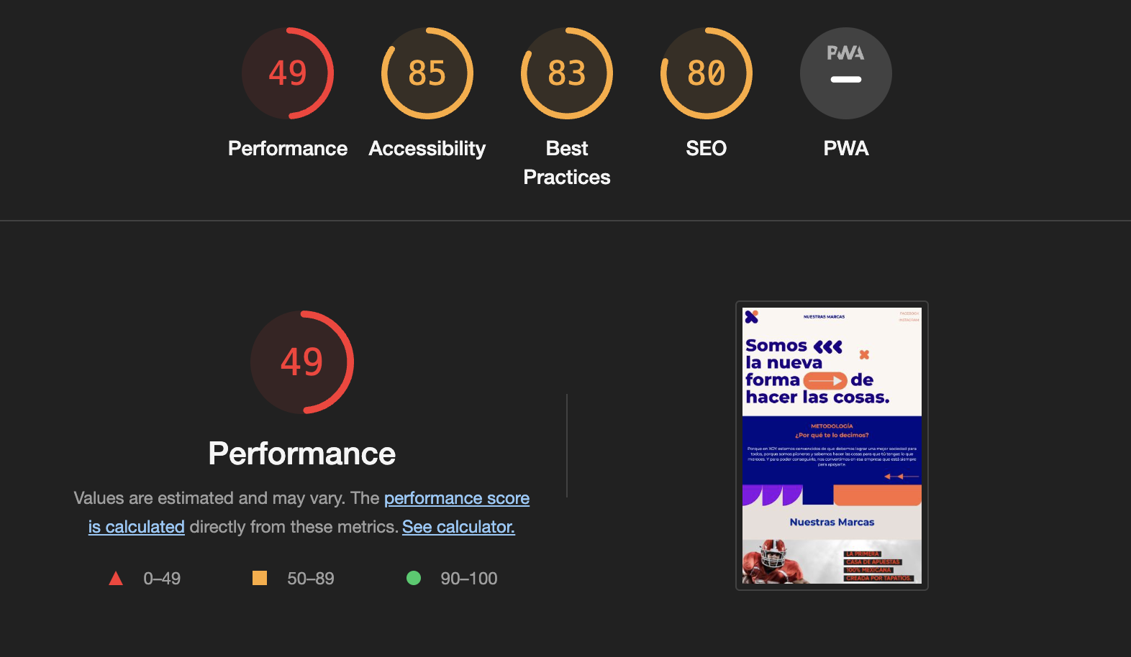

Analizing the result I could notice several places where the page could improve his performance.

1. The size if the images that uses, can be optimized by several online tool like TinyPanda and PicResize.
2. The use of new generation format images, could also improve the performance.
3. The webpage uses a lot of images it has an enormous network payload ( 5,434 KiB). As a recommendation, it could reduce the amount of images that display or take in consideration downgrade a little bit the quality of the images.